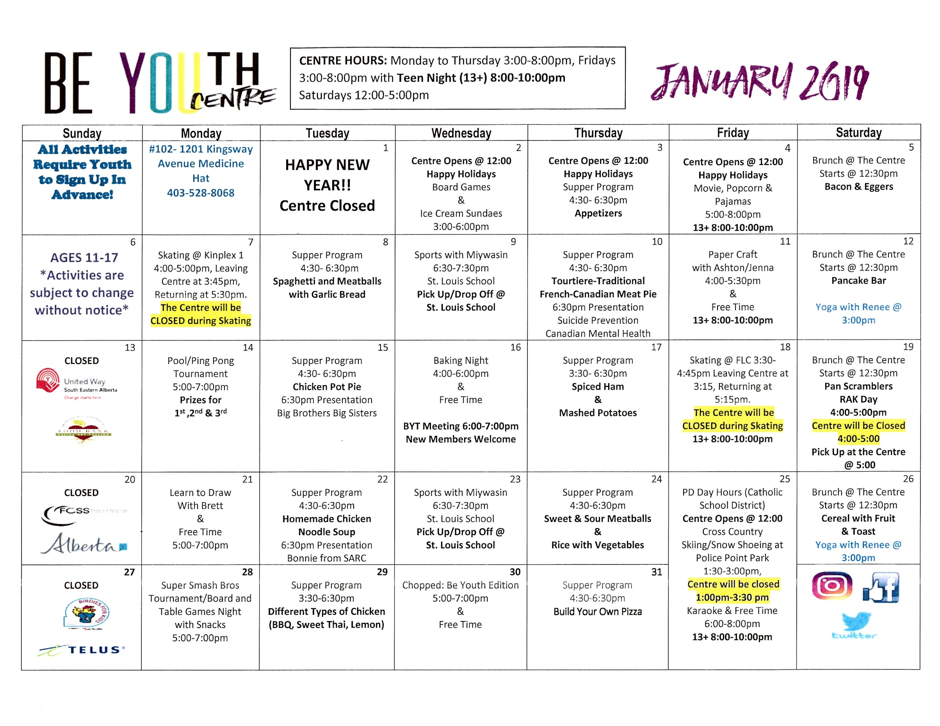

NOVEMBER 2020
The Be YOUth Centre is the place to be! Youth ages 11-17 come hang out, Monday to Saturday. We continue to provide free programming but please note some changes in programming due to guidelines pertaining to COVID19.
If you would like to be a part of the Be YOUth activities this month, please complete the sign-up sheets in advance of the all activities you are signing up for. Please return your completed sign up sheets to the Be YOUth Centre, and if you are new to Be YOUth, please come down with your parents to fill out the parent permission form, waivers and rules/expectation forms.
If you have any questions, please feel free to contact The Be YOUth Team.
Please return

Thank You,
The Be YOUth Team
403-528-8068 or text 403-502-2210

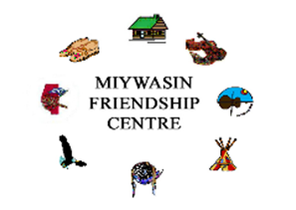

Name:__________________________
Sign Up Sheet for Activities
With a parent, please check off events that you would like to/can attend so we can be prepared. If you cannot make it to an event, it is crucial that you notify us as soon as possible. Please check our Facebook page for updates and reminders. Also, please dress accordingly for the outside activities!
Monday, Nov. 2
______ Hanging Purple Ribbons for MHWS 4:30-6:30pm
______ A Truth or a Lie Game 6:30-7:30pm
Tuesday, Nov. 3
______ Carpentry Night – Renovating BYC 4:00-7:30pm
Wednesday, Nov.4
______ All Stars Friendship Activity 4:00-6:00pm
______ Giant Tape Ball Game 6:30-7:30pm
Thursday, Nov. 5
______ Graffiti@ The Esplanade 3:30-5:00pm
______ Homework Program 6:30-7:30pm
______ LGBTQIA2s 6:30-7:30
Friday, Nov. 6
______ Skating@ The Leisure Centre 3:30-5:00pm (Leaving Centre@3:15)
______ Spin – A -Dare Game 6:00-7:30pm
Saturday, Nov.7
______ Speed Stacking Game 12:30-2:30pm
______ Karaoke Afternoon 2:30-4:30pm
Monday, Nov. 9
______ Veterans Night w/Special Guests 4:00-6:00pm
______ Sherlock Game 6:00-7:30pm
Tuesday, Nov. 10
______ Remembrance Day Jeopardy Game 4:00-5:30pm
______ BYT Meeting 5:30-6:30pm
______ Homework Program 6:30-7:30pm
Wednesday, Nov. 11
______ Centre Closed
Thursday, Nov. 12
______ Yarn Wrapped Monogrammed Letter 4:00-6:00pm
______ LGBTQIA2s+ Meeting 6:30-7:30pm
______ Homework Program 6:30-7:30pm
Friday, Nov. 13
______ Partner Picture Game 4:00-6:00pm
______ Get the Jar From The Toxic Area Game 6:30-7:30pm
______ Movie Teen Night 8:00-10:00(13+ Only)
Saturday, Nov. 14
______ Tablecloth Maze 12:30-2:00pm
______ Tik Tok Youth Challenge 2:30-4:30pm
Monday, Nov. 16
______ Indoor Badminton Tournament 4:00-6:00pm
______ The Postcard Activity 6:30-7:30pm
Tuesday, Nov. 17
______ DIY Stained Glass Art 4:00-6:00pm
______ The Fear Cap Game 6:30-7:30pm
Wednesday, Nov. 18
______ Ping Pong Blow Game 4:00-6:00pm
______ MHWS Presentation 6:00-7:00pm
Thursday, Nov. 19
______ Women’s Entrepreneur Day Speaker 4:00-6:00pm
______ Homework Program 6:30-7:30pm
______ LGBTQIA2s+ Meeting 6:30-7:30pm
Friday, Nov. 20
______ Indoor Video Scavenger Hunt 4:00-6:00pm
______ Wear That Game 6:30-7:30pm
Saturday, Nov. 21
______ Incoming Tide Survival 12:30-2:30pm
______ Hide & Scream In The Dark 2:30-4:30pm
Monday, Nov. 23
______ RAK Day Making Positivity Notes 4:00-5:00pm
______ Positivity Note Handout 4:30-6:30pm (Leaving Centre@ 4:30pm)
Tuesday, Nov. 24
______ Make a Deal Game 4:00-6:00pm
______ Living Sculpture 6:30-7:30pm
Wednesday, Nov. 25
______ DIY Clothespin Lamp 4:00-6:00pm
______ Homework Program 6:30-7:30pm
Thursday, Nov. 26
_____ Who Am I Game 4:00-5:00pm
______ DK Fitness 5:00-6:00pm
______ BYT Meeting 6:30-7:30pm
______ LGBTQIA2s+ Meeting 6:30-7:30pm
Friday, Nov. 27
______ Museum Hunter 4:00-6:00pm
______ Paper Bag Skits 6:30-7:30pm
______ Trivia Teen Night 8:00-10:00pm (13+ Only)
Saturday, Nov. 28
______ Board Games 12:30-2:30pm
______ Mario Kart Tournament 2:30-4:30pm
Saturday, Nov. 30
______ Taking Down Purple Ribbons 4:00-6:00pm
______ Scrapbooking Christmas Cards 6:30-7:30pm

Parent/Guardian Signature: _______________________________________________

