CENTRE HOURS: Monday to Friday 3:00-8:00pm Saturdays 12:00-5:00pm
OCTOBER 2020
Sunday | Monday | Tuesday | Wednesday | Thursday | Friday | Saturday
All Activities Require Youth to Sign Up in Advance! |  |  |  | 1  Cinnamon & Natural Wood  Candle Holders  4:00-6:00pm  What’s Your Motivation Activity  6:00-7:00pm | 2  Frisbee Tic Tac Toe @ Kin Coulee  4:30-8:00pm  Pickup @ Kin Coulee | 3  Say Anything Game  12:30-2:00pm  Yoga  2:30-3:30pm
4  AGES 11-17  *Activities are subject to change without notice* | 5  Eagle Butte Observatory  6:00-7:00pm  Leaving Centre@ 5:30pm  Returning@ 8:00pm  Centre Closed 5:30-8 | 6  Old Navy Workshop 16+  4:30-7:30pm  Possible Job Opportunity  Upon Completion of  Workshop! | 7  Old Navy Workshop  Day 2, 16+  4:30-7:30pm  Possible Job Opportunity  Upon Completion of  Workshop! | 8  Thankful Family Tree Vase  4:00-6:00pm  Homework Program  6:30-7:30pm | 9  Duct Tape Wars  4:30pm-6:30pm  Autumn Scavenger Hunt @ Kin Coulee  6:30-8:00pm  Pickup @ Kin Coulee | 10  Spray Can Art  12:00-2:00pm  Heads Up Game  2:00-4:00pm
11  #102- 1201 Kingsway Avenue Medicine Hat  403-528-8068  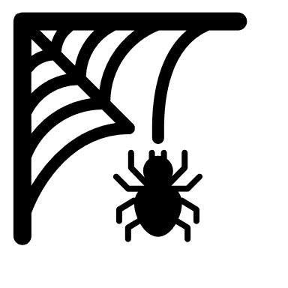 | 12  Happy Thanksgiving!!  Centre Closed | 13  Pictionary Relay  4:30-6:30pm  BYT Meeting 6:00-6:30pm  Decorate Centre for Halloween  6:30-7:30pm | 14  Glowing Leaf Jars  4:00-6:00pm  Time Bomb Game  6:00-7:00pm  Pumpkin Smash Fundraiser  Forms Go Home | 15  Fall Minute  To Win It  4:30-6:30pm  Homework Program  6:30-7:30pm | 16  Rake – A --Thon Fundraiser  4:00-7:00pm  Centre Closed 4:00-7:00 | 17  Rake – A – Thon  Fundraiser  12:30-4:00pm  Centre Closed 12-4pm
18  CLOSED | 19  Wood Rocks Epoxy Coaster Workshop-Part 1  4:00-6:00pm  Homework Program  7:00-8:00pm | 20  Wood Rocks-Part 2  4:00-5:00pm  RAK Day  Helping Homeless Bags  5:00-7:00pm | 21  Carving Pumpkins  4:00-6:00pm  CMHA -Presentation  6:00-7:00pm | 22  DIY Terra Cotta Candy Jar  4:00-6:00pm  Life Size Pac-Man  6:00-7:00pm | 23  Escape Room Night  4:00-7:30pm | 24  Board Games  12:00-2:00pm  Never Have I Ever  2:30-3:30pm
25  CLOSED | 26  Feelings Jenga  3:30-4:30pm  DK Fitness  5:00-6:00pm | 27  Halloween Family Feud  4:30-6:30pm  BYT Meeting 6:30-7:00pm | 28  DIY Reusable Bloody Handprint Décor  4:00-6:00pm  Self Esteem Card Game  6:00-7:00pm | 29  Painter Girl Night  4:00-7:00pm | 30  Pumpkin Smash Fundraiser  4:00-7:00pm | 31  Halloween Trivia  12:00-2:00pm  Halloween Party  2:00-4:00pm

